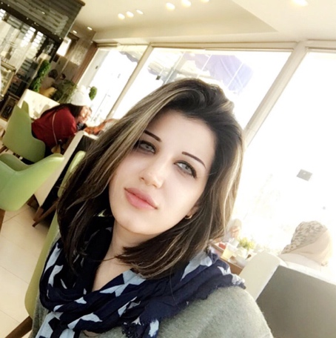

hadeel MOUHAMMED SHADHAN

Address **:** Iraq,Baghdad / al-jammea neighborhood

Email : hadeelmouhammed00@gmail.com

Phone : 07713433837 , 07712220264

# Experience

Flight and cargo documents translator at the Iraqi airways agency / Baghdad

Documents and researches translator at Al-Arabia bureau / Baghdad

# Education

BA in English translation at Al-MAMOON university college

# Awards and Acknowledgements

Member of Iraqi translators association

Worked for a short period as a supervisor at Al-GHAD schools

# skills

English language speaking and writing level 4

Microsoft office

Photoshop

# hobbies

Drawing

Reading

Playing piano